EDA

Ankita, Prasanna, Sambriddhi Kunwar
Westcliff University
Data 200
Professor Aayush Regmi
25th Jan, 2025

EDA
Project Title: Road Traffic Accident Analysis.
Exploratory Data Analysis (EDA) was conducted to understand the structure and characteristics of the road accident dataset. The main purpose of EDA is to identify patterns, trends, and relationships within the data. Descriptive statistics and visualizations were used to summarize accident-related variables. EDA helps prepare the dataset for further statistical or predictive analysis.
Descriptive statistics: The total number of accident records was calculated to understand dataset size. Frequency counts were used for categorical variables such as:
- Weather conditions.
- Road condition.
- Accident severity.
Numerical variables such as:
- Number of vehicles involved
- The number of casualties were summarized using mean, median, minimum, and maximum values.
These statistics provided a general overview of accident distribution.

Data Preprocessing and Cleaning:

Handling Missing Values
- Missing values were identified in variables such as weather and road conditions.
- Categorical missing values were filled using the most frequent category (mode).
- Records with too many missing values were removed.

Handling Duplicates
- Duplicate accident records were checked using date, time, and location.
- Duplicate entries were removed to avoid biased analysis.

Outlier Detection
- Outliers in numerical variables (e.g., casualty count) were identified using box plots.
- Extreme or unrealistic values were removed or adjusted.

Data Wrangling
- Date and time fields were converted into proper formats.
New variables such as:
- Hour of day.
- Day of week.
-Day/Night indicators were created to improve analysis.

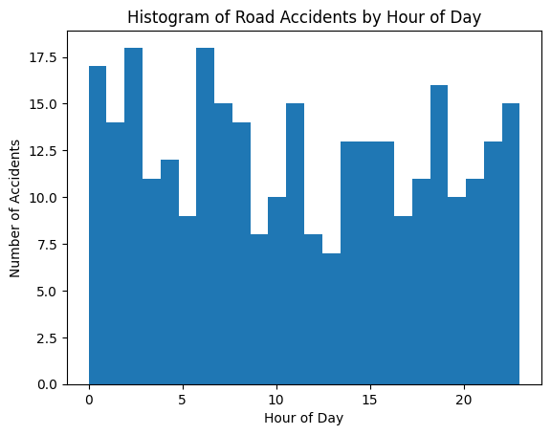

The histogram displays the distribution of road accidents across different hours of the day. Each bar represents the number of accidents occurring within a specific hour. Accidents are spread throughout the day, with noticeable increases during morning and evening hours, which correspond to peak traffic times. This indicates that traffic congestion and human activity play a major role in accident occurrence.

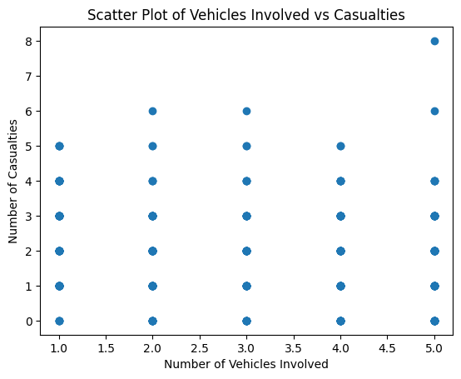

The scatter plot illustrates the relationship between the number of vehicles involved in an accident and the number of casualties. Each point represents one accident record. A positive relationship can be observed: accidents involving more vehicles generally result in higher casualties. This suggests that multi-vehicle accidents tend to be more severe compared to single-vehicle accidents.

